Function Flow:
The system is provided with 2 keys and 3 LEDS
- Keys
  - Selection keys
  - Navigation keys
- LED
  - Green- Motor LED- motor run indication
  - Amber-Pause LED- mode pause indication
  - Red- Fault LED – Fault indication

INITIAL SCREEN:
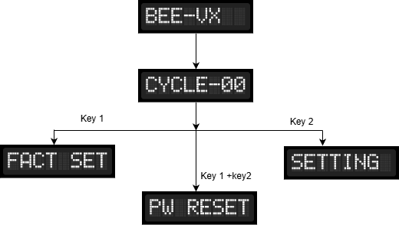

Initially: The system retrieves the Default mode and check for the home position Where the screen will display number of cycles from Default mode.

Key operation:
- Pressing Key1 navigates the user to the Factory Settings menu.
- A short press of Key2 displays the current setting.
- A long press of Key2 allows the user to modify the selected setting.
- Pressing Key1 and Key2 simultaneously initiates the Password Reset process.

Factory setting:

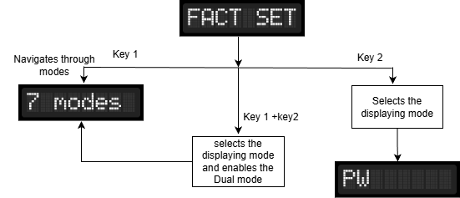

Seven modes:

- Pressing Key1 cycles sequentially through all seven available operating modes displayed on the screen.
- Pressing Key1 and Key2 simultaneously selects the currently displayed mode as the primary mode and allows the user to select a second mode, thereby activating Dual Mode operation.
Dual Mode is supported only for Single Point Stand-Alone and Multi Point Stand-Alone modes. For all other modes, the Key1 + Key2 action has no effect and Dual Mode will not be enabled.
- Pressing Key2 selects the currently displayed mode and prompts the user to either create a new password or enter an existing password, depending on the current system state.

Password Creation, Reset Procedure and Entry:

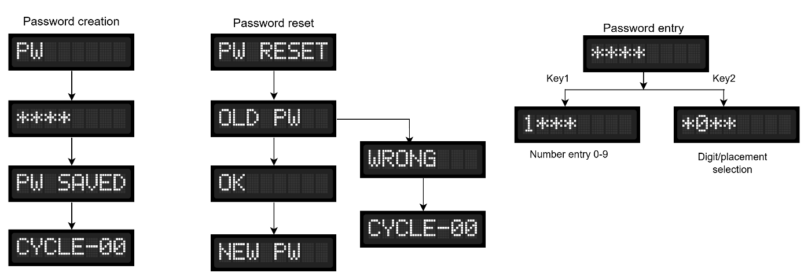

1. Password Creation
- When password creation is initiated, the display shows “PW”.
- The user enters the desired password using number entry (0–9).
- After successful entry, the system stores the password and displays “PW SAVED”.
- Once the password is saved, the system automatically returns to the Home Screen (e.g., “CYCLE-00”).

2. Password Reset
- When the Password Reset function is initiated, the display shows “PW RESET”.
- The system prompts the user to enter the existing password, displayed as “OLD PW”.
- If the entered old password is valid, the system displays “OK” to confirm verification and proceeds to prompt the user to enter a new password (displayed as “NEW PW”).
- If the entered old password is invalid, the system displays “WRONG” and returns to the previous operation without allowing password reset.
- Upon successful entry and storage of the new password, the system updates the password and returns to the Home Screen.

3. Password Entry

- When password entry is required, the display shows masked characters (e.g., “****”).
- Key1 is used for numeric entry (0–9).
- Key2 is used for digit/placement selection within the password.
- After the complete password is entered, the system validates the password:
  - If the password is correct, access is granted and the system proceeds to the requested operation.
  - If the password is incorrect, the user is prompted to re-enter the password.

User setting:
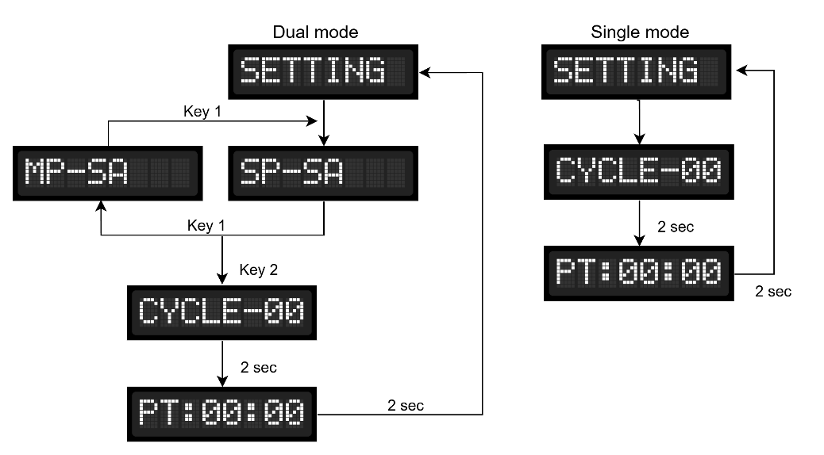

Mode Selection (Dual Mode Only)
- “MP-SA”: Represents the Multi Point Stand-Alone mode.
- “SP-SA”: Represents the Single Point Stand-Alone mode.
- Key Interaction:
  - Key1: Navigates between the two modes (MP-SA ↔ SP-SA).
  - Key2: Selects the currently displayed mode and enters the cycle setting.
Cycle Setting
- Key1 (Increment): Increases the cycle count.
- Key2 (Decrement): Decreases the cycle count.
- Timeout / No Key Action: If no key is pressed for 2 seconds, the system automatically moves to the Process Time (PT) setting.

Process Time (PT) Parameter
- Key1 (Increment): Increases the Pause Time value.
- Key2 (Decrement): Decreases the Pause Time value.
- Timeout / No Key Action: If no key is pressed for 2 seconds, the system exits the settings menu and returns to the Home Screen.

